TITANIC TUSCAN TRAVELS
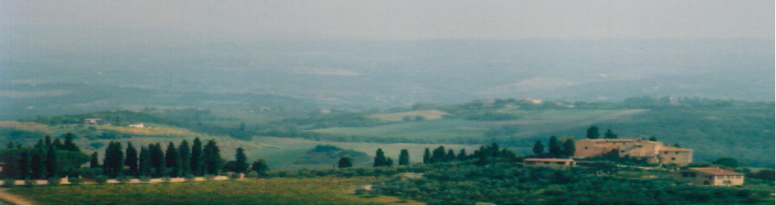(in tepid temperatures)

What a better way to start the tale of the Tuscan adventures than by making the first brew the day after Hallow’s Eve, otherwise on All Saint’s Day (November 1st)… as Italy happens to be one of the most pious countries in Europe.

Antoinette (Azzurro, to be considered as AA for sake of space) and I left Paris Orly on a rainy chilly day on one of our favor ite airlines… Easyjet, one of the premier low cost European airlines whose major advantage (over Ireland’s Ryanair) is to take off from the principal hubs (instead of Ryanair’s Beauvais… almost 1,5 hours from Paris ! ) Several years ago, I had been disappointed by Easyjet as I considered their blatantly low fares fallacious after having wanted to travel to Nice to visit the Simandl family in Grasse (near Cannes). The published fares on their orange-glow billboards were enticing (29 euros one way) but these fares seemed to be only available during the oddest hours / on weekdays / and not before at least six months down the road… what I did not realize is that Paris-Nice is the most sought of travel destinations by the Riviera-crazed Parisians !

Easyjet’s otherwise (very) low fares (76 euros round trip to Pisa) were attractive (we had used it to fly to Naples) as they have quick airport turnarounds (no food served unless paid for at hefty prices), only one onboard baggage, and access to the plane (you choose your own seat) according to your arrival time at the ticket counter (spread into four groups). Despite taking off at an ungodly hour (8 AM forcing us to wake up at 5:15 AM), all went well and the one hour twenty minute trip went without a hitch. The Parisian weather seemed to be pan-European as it was drizzling in Pisa upon our arrival. We eventually learned that it had been raining non-stop for almost two weeks ! Just to let you in on a secret : the following day and through the rest of the entire odyssey, we had BEAUTIFUL weather !! AA, knowing the Italian climate well, dreaded the autumn Tuscan season as October happens to be the second wettest month (after November) for the region.

I had rented a car on the Internet by simply choosing the lowest price on the smallest model since we were only to be two with small suitcases. Using ArgusCarHire.com, I had opted for a three-door Fiat Punto (our motto : when in Tuscany, do like the Touchtones)… we eventually had an upgrade to a five-door Smart Passion… the key in my opinion behind the upgrade was to do it only three days before our departure (latest possible) so that if the option was not available, we would get the better car (with sliding roof to boot). We did not choose the extra insurance (in total, almost the entire cost of the car for the week) as I bet on my lucky star…

What is nice about the Pisa Galileo Galilei airport ? You leave the airport and within 100 yards, you are already in the city of Pisa… our only destination in this lack of tourist site city was as you can all imagine… the Leaning Tower of Pizza. Located in the northwestern tip of the city (partially walled in), our wayward tower temporary destination did offer us a few problems as one-way streets and totally forbidden roadways (we even took one through the market square and only realized later that it was totally illegal) made the eventual access labyrinthian (this dilemma made the rest of our on-road trip difficult in all the Tuscan cities).

Pisa dominated the Western Mediterranean between the 11th and 13th centuries thanks to its powerful navy and trade with Spain and North Africa. Oddly enough, its decline began when the city’s river (Arno) began to silt up creating a salt marsh now dividing the city from the sea. During its heyday, their cultural revolution led to several splendid buildings of the era. 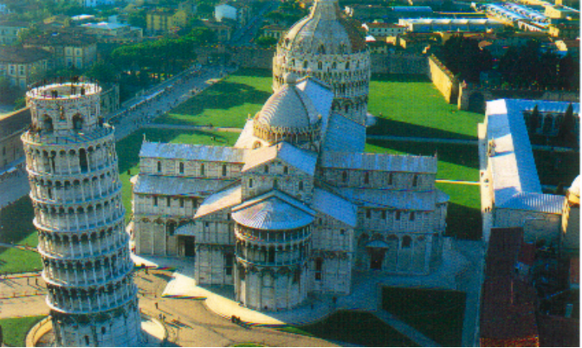The Tower is only one of the religious edifices to sprout up from the Campo dei Miracoli (“Field of Miracles”) including the Duomo, the Baptistery (the building for baptisms and usually separated physically from the cathedral or church… all over Italy) and the Campo Santo Cemetery (containing earth from the Holy Land). The architecture of all the buildings were Moorish including inlaid marble in geometric patterns (arabesques) with Romanesque colonnades and spiky Gothic niches and pinnacles. We did not visit the most ancient Duomo (meaning cathedral… began in 1063) but went directly to that most awkward looking of creations, the leaning tower. Known as the Torre Pendente, the first stone was laid in 1173 and eventually completed in 1350 (or 177 years !! ) The tower began to tip before the third floor was even finished in 1274 (took 100 years just to get to this point out of a total of eight floors) !!! The tower is supported on shallow stone slabs only ten feet deep embedded in sandy silt subsoil (with whiffs of clay, stone and rubble). The belfry (or bell tower) added in 1350 brought the total height to 179 feet as its seven large bells just added pressure to the kilter. Today, the tower is leaning about 18 feet from its vertical axis… and I felt a bit of pity for the locals in their abodes beneath the potential crush as surely this tower will fall… eventually. Recent engineering interventions have corrected the tilt by 14 inches (enough ? ) and the visits to the tower were only reopened in December 2001 (when looking up at the tower from the ground, it may be an optical illusion but it seems that the bell tower is slightly straighter than the rest). The core of the tower is empty as the staircase winds around. We waited in line and just missed the tour so we had 1,5 hours to kill (we were able to have lunch)… the marble steps were worn down on the different sides as we made our way upwards and you could feel the “lean” in the structure making it a bit difficult (AA was teetering). I was not able to walk up with my video camera case (barred at the door) as any large object was considered a bomb… so it had to be left inside a locker with other rucksacks near the ticket counter across the miraculous field. The views from the tippy (or tipsy) top were incredible as we dwarfed the nearby duomo and baptistery. It was slightly slippery and windy (the rain had halted) and the guardrails were ridiculously flimsy allowing any nutcase to end his days on purpose… or on a day like today by accident due to the slippery slope !!

Back to the car parked in a nearby public garage (paying of course) and we were off to the east and then south to arrive at our lodging at the Castello di Montalto (about 23 km east of Siena). We could have taken the highway all the way but this would have added about 70 km through the outskirts of Firenze (Florence) before plunging on a southerly course to Siena and then east. We decided to leave the highway as early as possible (eventually ended up going by the airport once again) and make a bee-line to Siena through the countryside as we had time on our hands. We stopped off to stock the larder as we knew we had an equipped kitchen upon our arrival.

When we had rented out our lodging at the Castello, Vicki Uslaner, our timeless travel partner (Prague, Napa, California, etc) was originally part of the travel plans… but she had the opportunity to transfer out of the backbiting Parisian George V Four Seasons Hotel and hie off to the San Francisco region for FS marketing on a more global basis. We missed her joyful company…

So… we ended up with a two bedroom, two bathroom and kitchen apartment (there are also small independent houses) but all was not lost. AA had friends in from Rome staying with us overnight… Barbara (pronounced Baabi) and her husband Domenico. AA and Baabi know each other from AA’s time in London where she worked with Goldman Sachs for several years.

The castello, located at the end of a winding and earthy two mile lane (a bit out of nowhere) offered many services which we eschewed (breakfast… only the first day ; a pool - closed ; ping pong ; sale of its own farm products - wine & olive oil ; guided tours - who needed those with AA having contacts ? ; cooking classes ; tennis court ; bocce ball ; trails around the castle ; etc). Sounds great for the summer when you want to loll around but we were there for cooking dinners and sleeping… this was AA’s third time to the castello as she had been previously with her Australian family and once with friends.

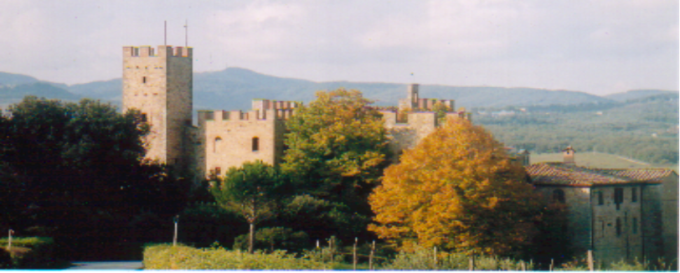Geographically, Castello di Montalto is officially in Chianti (Chianti, or at least the wines for me, was west of Siena) and very centrally located for touring and lies about 125 km from Pisa, 80 km from Florence and 230 km from Rome to the south). The owners (Giovanni and Diana Coda-Nunziante) who live in the castle have a total estate of 700 acres. And they can lodge up to 50 guests in their 9 different guest houses/rooms. Giovanni and Diana came by to visit us the first night (I never saw them again as a few days later they flew to the US to see one of their children)… Giovanni is of the old Italian aristocracy… and Diana is an American… sound familiar ?

We made ourselves at home in the apt… there are a few key things to make one’s stay more agreeable (practiced in most of our destinations) which must be transported from Paris : a bottle of pink de Telmont champagne to baptize the arrival, AA’s Ipod with accompanying speakers, a brochette of several trashy magazines (Gala, etc) and the video camera to capture on tape those treasured moments… and not having TV. We even bought on the way to Siena a bottle of lemoncello (lemon liqueur) which had nothing to do with AA’s homemade version back in Paris with pure alcohol and true Sicilian lemons.

The night of our arrival, Domenico and Babi invited us out to a very fancy restaurant (the Relais Villa Arceno dating back to 1671) in nearby San Gusme (literally only about 1,5 miles away by a straight line but about 15 minutes by car as there was not a direct road). It was a three star hotel and the restaurant was fit for a king with very few and spread out tables (funnily enough, we had Domenico and Babi last night as they are staying in AA’s newly purchased rental apt across her terrasse for four days). Some highlights of the repast : ravioli stuffed with pecorino (local cheese made from sheep’s milk) and parmesan fontina with paper-thin slices of truffles ; main course of lamb stuffed with roasted mint and thyme. Wine : 1997 Nobile du Montepulciano (more below), Cantina de Reserve.

On Sunday (October 9th), Domenico took the wheel as we all scampered into his car and headed south for travels into the Tuscan wine country of heralded vineyards of the Montalcino and Montepulciano regions (these are actually towns). As he mostly took country roads (always winding… more about my impressions of Italian driving later), we drove through Asciano, Buonconvento and Montalcino in order to get to mass (yes… Sunday morning) in the renowned Abbey di Sant’Antimo by 11 PM (over one hour away). Founded, according to legend, by Charlemagne in 781, this Benedictine church has inspired poets and painters with its setting against a background of tree-clad hills in the Starcia Valley. The exterior is decorated with interlaced blank arcades carved with symbols of the four Evangelists. We were able to listen to the elderly Augustinian monks who sang the Gregorian chants… the unfortunate aspect was that the sermon was about fifteen minutes - 8 minutes over the limit would howl my French grandmother ! - and the entire mass was one hour and fifteen minutes, too long for any devout Catholic.

We were off eastbound to the town of Pienza, which I would characterize as the typical Tuscan village with… its massive Renaissance-style Duomo (Pope Pius II ordered it built in 1459) and the surrounding lanes filled with tourists buying all the local wares. Known as the “ideal” or “utopian” city due to the fact that it was one of the best planned Renaissance towns with a model of ideal living and government. Hmmm… maybe Macchiavelli was here…

Off to the hamlet of Montefollonico where we walked down memory lane for Domenico and Baabi as they had their “secret” rendez-vous here while they were courting at times far from Rome. They brought us down to the end of a road where from atop of a cliff/hillock, we had an amazing view of the Tuscan countryside far below, a view known as the “End of the World”.
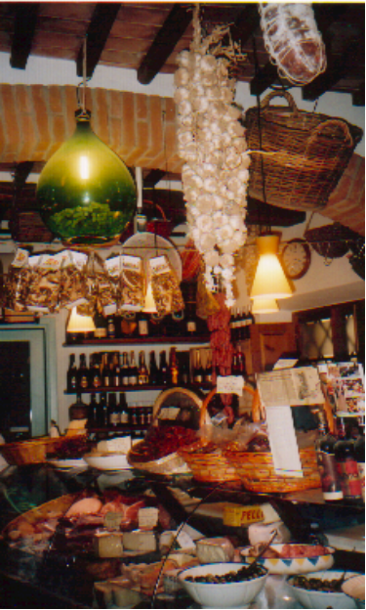
The town of Montepulciano was next on our hit list built high on a narrow limestone ridge and which can be seen from far, far away… even from Montefollonico. At 1950 feet above sea level, it is one of the highest of Tuscany’s hilltop towns. Parking outside the walled fortifications (built in 1511 for Cosimo I), we walked a long winding street called the Corso which ended in the main square crowning the summit of the hill. The streets are crammed with palazzi (palaces) and churches and the town is principally known for its delicious local Vino Nobile wines (made with Sangiovese grapes on the Tuscan hills, the grape being the base for all Tuscan wines). Upon our walk back, I had my first and only gelato (special Italian sorbet) of the trip (a mix of melon and cherry in a cone). We eventually drifted back to our castle in the air as D and B had to head back for the two hour plus trip back to Rome. Thanks to Domenico’s driving (like a real Italian), I was able to videotape directly from the car, a feat which would be quasi-impossible for the rest of our trip.

Monday, October 10th

AA and I had to base our schedule around a wine-tasting session near (as usual on top of a hill) Montalcino (we had blown by the day before) the home of the “brunello” wine, the aristocratic red wine of Sangiovese fame. We were able to park inside the walls (yet paying… as usual), and we walked around to once again see many churches and the local duomo (every town MUST have one). At every narrow, winding and steep street corner, there were enotecas (wine bars or tourist traps ? )… just trying to get you to purchase the brunello of the day. We stopped by the 14th century “Rocca” or Fortezza, an imposing abandoned castle with its spiked angular towers. From its ramparts (built by Cosimo I in 1571), one can supposedly see on a crispy clear day the islands of Elba and Corsica ! We just saw the Orcia Valley and the Umbrian mountains.

We had little time in Montalcino before venturing off to our wine-tasting only five minutes away at Poggio Antico, a very modern vineyard (only since 1980) and the young German tour guide (two other American couples with us from the same family) had been brash enough to qualify their wines as the “King of brunellos” (with the crown on their bottle). This wine-tasting had been set up by our contact David Fink, a wine aficionado himself who had let us stay in his hotel in Carmel-by-the-Sea in California. The guide left us with few warm memories as her horse laugh (at almost every comment) and just the commercial aspect of the entire tour (she had been there for only six months) made us want to bee-line for the tasting… the vats were all stainless steel and the barrels were in underground refrigerated compartments unlike the real thing… and these guys are the Kings ??? After the tasting (free for us thanks to David’s connection… 15 euros a pop for the others). AA ended up buying three bottles including the Brunello “reserve” di Montalcino (1997) for a lofty 43 euros… their “cheapest” bottle was a 2003 Rosso di Montalcino at 15 euros, with 27 the next category and up to 67 euros for a Brunello di Montalcino (1988)… or was that the price for the case…
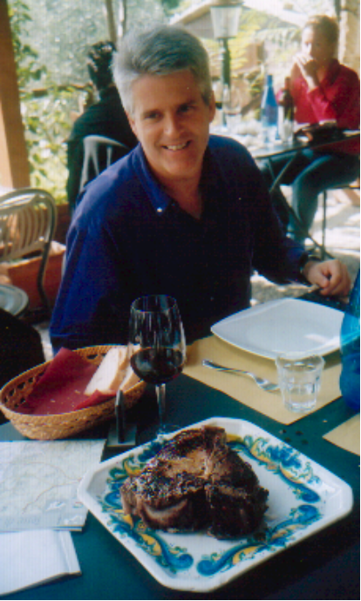
We headed off to Bagno Vignoni but bypassed it hoping to reach a restaurant in Monte Amiata (30 minutes later) and found out that it was the wrong town (it didn’t even have a bar) so back to Bagno for a very late lunch (2:15 PM). Bagno Vignoni is known for its sulphurous hot spring thermal baths used during the Middle Ages and Renaissance. Clients included St. Catherine of Siena (1347-80… and more on her later) who had scrofula (form of tuberculosis) and Lorenzo de’ Medici, or the Magnificent (1449-92) with arthritis. The pool is no longer open for bathing but the arcaded, stone lined pool is worth the architecture. We were famished and ended up in a trattoria (a typical Italian restaurant) with AA and I splitting a 1,3 kilo Florentine steak (this just had to be done before our departure). I also had wild boar carpaccio as an appetizer plus a glass of Montalcino Nobile wine (noblesse oblige).

Off we were to the northeast to Cortona (tack on another hour), a partially fortified city built into a hillside à la Minas Tirith in the Hobbitt trilogy. Cortona is one of the oldest Tuscan cities, founded by the Etruscans (they immigrated to Italy from Asia Minor in 900 BC and they are known for animal sacrifices and reading the will of the gods in animal entrails and … cloud patterns - they were eventually eclipsed by Roman rule in 395 BC) and was a major seat of power in medieval times. It was “sold” to Florence after being defeated by Naples (much further south ! ) in 1409. We parked outside the city walls and immediately had to climb steep streets just to arrive at the flattish main street. We visited the Museo dell’Accademia Etrusca, one of the regions most rewarding museums with a Etruscan bronze chandelier dating back to the 4th century BC and an Egyptian wooden funerary boat (2nd century BC). Afterwards we walked to the western part of town to via Janelli, a short street with some of the oldest surviving houses in Italy with their overhanging upper floors built out on massive timbers and partially supported by wooden tresses poking out of the building on the ground floor. We had to head west back to our castello and it was pitch black as we had to take winding mountain roads… and had difficulty in getting our bearings (more on Italian driving later).

Tuesday, October 11th

This was to be the day of attacking the “capital” of Tuscany, as we had to get up at 7 AM (is this a vacation ? ) and we had to be in central Florence at 10 AM in order to rendez-vous with our guide (set up by AA). We left at 8:00 believing that two hours would be widely sufficient… but ten minutes later, we were abruptly stopped several miles outside of Siena due to road work and eventual one-lane “rush” hour traffic. We lost over 25 minutes on this bit but tried to recover on the northern leg between Siena and Florence. Then just outside of Florence (the city doesn’t have a beltway), the traffic backed up (reminded me of coming into Los Angeles from northern Santa Barbara) as we were funneled into the southern suburbs… finally getting to the Arno River (cutting thru Florence from east to west) at about 9:55 AM. Our meeting point was at Piazza Republica with our guide Violetta. Since we had seen cars in the city (driving like nuts and with swarms of Vespas or mopeds which we had not noticed elsewhere in Tuscany), we did not believe in having parking problems but one-ways prevented us from getting to the city center (we learned later that only residents could advance to the center). We called our guide to vent off our frustration and she eventually walked the five minutes which separated us… we were parked in a residential spot (totally illegal area without a parking sticker) and our guide suggested a public parking with attendant inside a building which she had just passed on the way. We had driven into one earlier much further away only for the guy to say that it was booked solid for cars staying the whole day !!! We finally lucked out with this one (only 21 euros for the day instead of the probable 35 euro fine… plus potential boot or tow away) which was much closer to our final meeting spot but AA can definitely admit that I was fuming in the car due to the inefficiency of the Italian system. We were ready to “rock” at 10:30…

We were back in the main plaza before heading off to see… the Duomo (or Santa Maria del Fiore) holding up to 20 000 people and whose dome (1436) was designed by Brunelleschi to at the time dwarf even the great buildings of ancient Greece and Rome… and without any scaffolding, considered revolutionary at the time ! The sheer size was typical of Florentine determination (especially against its archenemy Siena) to lead in everything as the cathedral still stands as the largest building in the city. The separated baptistery in front of the main entrance of the duomo is one of the oldest buildings in Florence dating back to the 4th century. Its renowned doors christened as “The Gate of Paradise” by Michelangelo were crafted by Lorenzo Ghiberti between 1424-52 and portrays ten polished brass panels with scenes from the Bible… commissioned in 1401 to mark Florence’s deliverance from the Black Death (or 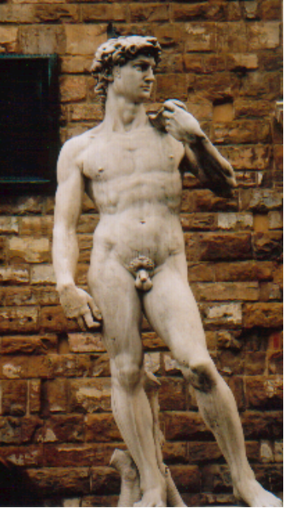bubonic plague), which wiped out up to half of Europe in several regions. To make this church unique, there is also a separated campanile (very tall rectangular tower) to the right in white, green and pink marble with the top (276 feet) only being 20 feet shorter than the tip of the dome. In front of the duomo, swarms of tourist groups with their respective guides hustled and bustled as they literally fought for room on the plaza. These groups were of diverse origins : US, French, Italian, Asian (several countries) and even one from India… the line into the cathedral was lengthy and it was not in our plans anyway. Our goal for the day was to visit the Galleria dell’Accademia (or the Academy of Fine Arts) and the Uffizi (meaning “offices”)… it took a five minute walk to the Academy and there was a 2,5 hour long line serpenting around the building… why the long line ? To see Michelangelo’s David (the slayer of Goliath) of course. Founded in 1563, the Academy was the first European school to teach the techniques of drawing, painting and sculpture. Many of Michelangelo’s most important works have been housed here since 1873 including the David (17 feet high) which had to be removed for protection from the weather and pollution. Two other smaller replicas are located elsewhere in Florence, one which we had seen in Piazza della Signoria (near the Uffizi), an outdoor sculpture gallery including Cellino’s bronze statue Perseus (holding Medusa’s head), the Neptune Fountain (commemorating Tuscan naval victories… Neptune’s hand had been missing as some tourist had sat on it a few months ago… and it broke…), and a copy of the writhing figures in Michelangelo’s The Rape of the Sabine Women (1583).

We were able to “sneak” into the Academy as our official guide was able to get us in way ahead of our original afternoon appointment. Before espying the original David, we saw the original Rape of the Sabines and several unfinished works of muscular slaves and gods struggling to free themselves from their marble prisons. It was interesting to see the David, marble sling, shlong and all but… no way would I have waited over two hours for this oeuvre d’art.

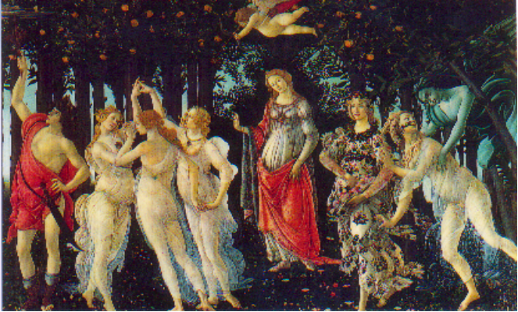Off to the Uffizi built in 1560-80 for Duke Cosimo I’s new administration offices - haven’t we seen this guy everywhere ? - Cosimo’s heirs used the museum to display the Medici family art treasures creating what is now the oldest gallery in the world with plans to double the entire exhibition space by 2007 (watch out oh sacred Louvre ! ) The works of art were finally “donated” to the Florentines in 1737 by the last of the surviving Medici, Anna Maria Lodovica. According to the guide, the Americans favorite work is of course Botticelli’s The Birth of Venus (1485) showing the Roman goddess of love, after being born in a storm in the Aegean Sea, she is blown ashore by the winds and awaited by nymphs holding a cloak in which to wrap her body. I was looking forward to this also, the memory dating back to my youth as my brothers and I were quizzed with famous painting flash cards at the dinner table.

We were able to see other great works of the pre- and Renaissance era : Giotto (1266-1337) and his Gothic art ; Piero della Francesca (1410-92) and his Duke and Duchess of Urbino ; Fra Filippo Lippi ; Botticelli’s other works Primavera and Adoration of the Magi ; Leonardo da Vinci’s The Annunciation and another Adoration of the Magi (unfinished) ; Raphael ; Titian and even Michelangelo himself (a very versatile and tortured being). Other European artists were displayed with Caravaggio and the Dutch masters Rubens, Van Dyck and Rembrandt. Our guide gave us the origin of the word “grotesque” which comes from the paintings on the ceiling of one of the long corridors. The ugly characters and (m)animals portrayed in absurd positions originally were discovered in caves or grottoes… we had heard a comment from tourists in the streets that Florence was the greatest art city in the world. Violetta, our guide, said that unfortunately this was not so… as Paris was clearly the leader as many of the great Italian works (aka Mona Lisa) were shipped off to France… some by Napoleon’s “request” and other by Italian artist “defections”.
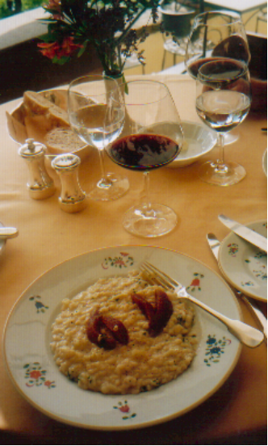
After bidding farewell to our guide, we took a private shuttle bus to a northern suburb called Fiesole as AA had reserved our lunch at the luxury hotel (Orient E xpress chain) Villa San Michele which had astounding views of Florence as we were perched on the patio in the hills overlooking the city far below in the afternoon mist. The menu of risotto with Taleggio cheese and caramalized pears, followed by guinea fowl in vanilla pod sauce and vegetable flan. The wine we had was a 2000 Boscarelli Vino Nobile di Montepulciano.

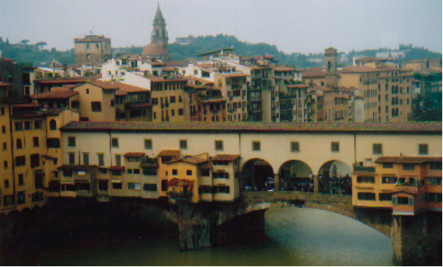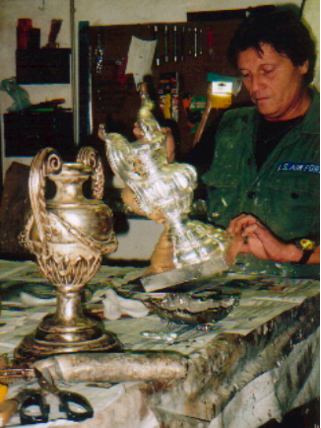After our return shuttle, we walked to Ponte Vecchio (Old Bridge) which like its namesake happens to be the oldest and most popular bridge in Florence dating back to 1345, designed by Taddeo Gaddi, Giotto’s pupil. It was the only bridge to escape the WWII bombing and the original workshops filled with butchers, tanners and blacksmiths had given away (since 1593 due to the noise and stench) to high street goldsmiths specializing in new and antique jewelry. The oldest workshops have rear extensions overhanging the river supported by logs à la Cortona method. On the opposite southern side (very few tourists), this was a neighborhood of small houses and shops selling antiques as well as artisans crafting their wares (furniture, silver, gold, etc) while chipping, drilling, inserting gold leaf, etc. We walked by the Medici’s Palazzo Pitti, a palace originally built for a wealthy banker (Lucca Pitti) in 1457 and sold to the Medicis a century later (the Pitti heirs were bankrupt) for it to become the main family residence… all later Florentine rulers lived there and today it houses several museums. We dove into the small side streets before heading back towards the car… and stopping off at the world’s most prestigious and beautiful “pharmacy” or erboristeria - herbalist - (Officina Profumo/Farmaceutica di Santa Maria Novella) filled with perfumes and aromas (you get sick to your stomach after awhile) in this most cloister-like of cadres with its ceiling frescoes. AA was disappointed by many of the exotic elixirs made either by the Camaldoli monks or the more recent concoctions sprayed on those little white sticks… but she ended up buying a herbal bath gel anyway.

We picked up the car and decided to return using a different method : trying the Italian toll highway (heading east) for a few exits before bee-lining south straight to the castello. Unfortunately we missed our exit (all exits were separated by a lengthy 20 miles unlike in the US and France) due to the fact that the only sign was only about 500 yards before the exit… it was dark… I was in the left lane, large trucks were rumbling along in the right lane (only a two lane highway). We eventually got off at the next exit and paid the toll (all automated with no personnel !!) and realized that this was not the right exit… had to get on to get to next toll to have a “better” road to get back. We ended up losing way over an hour, did maybe an extra 70 km (to compensate for the kms saved between Pisa and the castello) and ended up on sinister winding mountainous roads (we were all the way near Cortona when we headed back west).

Wednesday, October 12th

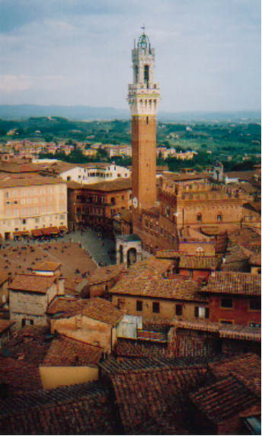
Nuts… we had to be up at 7:15 for our appointment at 9 AM with another guide to visit the second largest city in the area… Siena. This time we were prepared for the road delays as we left at 8:15 for a normal twenty minute trip. The delays were not as bad as the prior day… and we still arrived ten minutes late as we ended up at a northern door of the walled city instead of a desired more proximate (to the castillo and meeting point) southerly one. Paid parking had to be done for all tourists once again but even the local residents have outside-the-wall reserved parking areas. To get to the main plaza, we had to climb a very steep drive… with houses/apartments on each side… I mean these people are crazy to live like this. The principal sights are located in the network of narrow streets and alleys around the fan-shaped Piazza del Campo (where we met Laura Meattini, our guide). Hardly any street is level since Siena, like Rome, was built on seven hills. At one point, you have a fantastic view of the city, then a few yards later you are engulfed by the medieval houses. Aerial bridges and corridors linking buildings on opposite sides of the street are typical architecture. Siena is an interesting city due to the competition that exists between the 17 contrade (or parishes) whose animal symbols are everywhere on carvings, plaques and street signs. The buildings around the Campo (or field) symbolize the golden age of the city between 1260 and 1348 (one building is the Palazzo Pubblico, the graceful Gothic town hall completed in 1342 and embellished with a 330 foot belltower, the second highest medieval tower in Italy). Siena’s decline began in 1348 when the Black Death besieged the city and killing almost half the population… and then around 1550, thousands more were mortally wounded in an 18-month siege by the Florentines (they are still “enemies” today). The victors repressed all further development and Siena sort of remained frozen in time, thus still crammed with medieval buildings only undergoing renovation presently.

Laura told us of the folklore (and the tradition even continues today) which makes Siena unique… the Palio is Tuscany’s most celebrated festival taking place on July 2nd and August 16th each year around the Campo. It is a bareback horse race dating back to 1283 with the jockeys representing the 17 districts (but only nine horses run at a time - by drawing straws - due to the lack of room). The races are preceded by heavy betting and the race only lasts 90 seconds (twice around the main square which has mattresses erected on the sides of the buildings where you have the harshest turns). Supposedly huge amounts of money are paid for a ringside view of the race (up in or on top of the buildings). Thousands of people cram into the middle of the piazza. It is a no-holds barred race meaning you can whip, tug, pull your competition (horse and jockey) instead of prodding your own stallion. What does the winner get ? Only a banner (or palio) but social recognition which will last a lifetime. One jockey has won twice in the last three years but under different “colors” as he contracts himself to the highest paying parish… what a life !!

We were off to see the wizard (oops… the Duomo)… and the facade had scaffolding (due to… renovation) but they had a picture painted on the scaffold netting which was mighty impressive. This duomo happens to be one of the most spectacular in Italy. The Sienese were in constant battle with Florence to have the largest cathedral… and in 1339 when Siena wanted to add on a new nave making it the largest in Christendom, the Black Death hit and only the far wall of the unfinished nave was completed (an open-air parking lot became the rest and you can even have your car parked above one of the column bases). We were very lucky as we visited the duomo later in the afternoon (without our guide) as the inlaid marble floor was absolutely magnificent… and only uncovered two months a year !!

Around 1 PM, we ended our guided visit at San Domenico, a behemoth of a barn-like Gothic (and ugly) church completed in 1340 (114 years to complete). But inside, there was an exquisite chapel built to store Saint Catherine’s (Siena’s patron saint) well-preserved head which is now kept in a gilded marble tabernacle on the altar. It reminded me of the unveiling of Sean Connery’s head (by Rudyard Kipling) in the movie The Man Who Would Be King. Saint Catherine’s withered finger (what ? after all those thermal baths at Bagno Vignoni !!! ) can also be seen (close up) under glass a few yards away from the chapel. Supposedly Catherine experienced many of her visions and received her stigmata (body lesions representing Christ’s wounds) in this church.

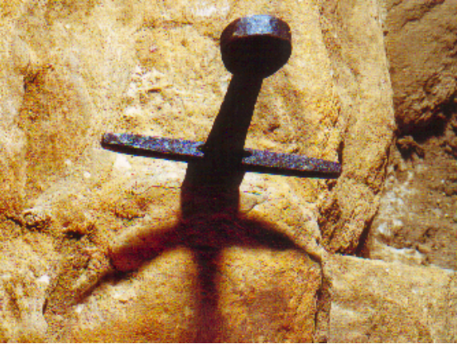We left Siena at about 3:30 PM and headed southwest to San Galgano (not in our original plans), one of my favorite destinations of the trip (but a bit out in the boondocks)… one hour later, we arrived at this ruined roofless Cistercian abbey parked in a dense woodland. Begun in 1218 by the local monks who despite espousing poverty became wealthy by selling wool from their sheep flocks. The abbey was corruptly administered (sounds like Opus Dei of the da Vinci Code) in the 14th century and eventually dissolved in 1651. But the real attraction of the area is what you will discover inside the beehive-shaped chapel of Montesiepi (built an even earlier 1185) perched on top of a nearby hill. The legend of King Arthur and Excalibur (one of my favorite movies of all time… move over !! )… the sword in the stone legend is no longer a fable ! In the middle of this chapel, Saint Galgano’s sword is literally embedded in stone (almost up to the hilt). Galgano, the son of noble parents, was born in 1148 and he grew into a brave but dissolute young knight. He saw his life as futile and turned to God, thus renouncing the material world. When he tried to break his sword against a rock as a symbol of his rejection of war, it was swallowed by the stone. Of course he interpreted this omen as a sign of God’s approval. He built a hut on the site (now the chapel) and eventually died a hermit in 1181. Pope Urban III declared him a saint and an example to all Christian knights in 1185.

Today due to vandalism, the sword’s hilt is covered by a square meter of domed plexiglass which is unfortunate. AA and I befriended the woman owner of the shop (and warden of the sword) alongside the chapel selling locally-made herbs, wines, olive oils, etc who had been working there for over forty years… and who pitched out a few stories. About one year ago, she heard a crash as vandals broke the glass covering and stamped on the sword end thus breaking it and the “curator” eventually had to patch it up (you can barely see the repair). We stayed with her about one half hour before heading off to a wine bar down the slope for a glass of local vino (AA had a local chardonnay while I tested a biologically enhanced red wine… which turned out to be awful and slightly fizzy). I bought some honey-flavored grappa (Italian fire-water liqueur) and even some special grappa glasses (with small bulbs at the bottom). Instead of taking the highway back to the castello, we stuck to the more direct route of smaller winding mountain roads (as you can tell, during our entire trip we preferred to avoid the big roads).

Thursday, October 13th

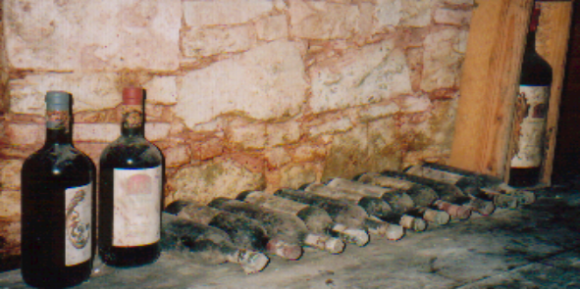This was our first lazy day (for once) as we left at 11:15 for San Gimignano (known as the “City of Beautiful Towers” with 14 of the original 76 windowless towers still standing dating back to the 13th century), a walled in well-preserved small fortress town (sound familiar ?) with its distinctive skyline northwest of Siena… not being rush hour, we almost sailed through the one-lane road delay and arrived one hour later in this medieval perched-on-top-of-a-hill-town (again, sound familiar ? ). The town lay on the main pilgrim route between northern Europe and Rome before the pest and the route’s eventual diversion led to its economic decline (revitalized since due to tourism and local wine production). We ended up parking in the final third potential parking lot (furthest from the town) as the other two were crammed with… tourists. Our favorite moment was actually on the path outside the city walls with silence and gorgeous views of the Tuscan countryside below. Then we were off to our second pre-programmed wine tasting session of our trip as we had a private tour of Castello della Paneretta (in Barberino Val d’Elsa… closer to Siena), specializing in chiantis, the less noble wine versus the reputed brunellos. Our guide was fantastic !! English speaking, we spent some time listening to the castle’s history, went inside for a tour and then down into the cellar (with sealed up secret passages, etc), then finally back up for some excellent wine tasting (for this we had to chalk up some euros… a few bottles were purchased including a magnum of their better quality wine as well as a bottle of spicy local olive oil). Wine-making dated back to 1596 (unlike the newness of Poggio Antico) and the well-known Strozzi family purchased it in 1696 and eventually sold it in 1984 to the Albisetti family (who rarely live there). Owning 309 hectares (mostly woods), it only produces 700 hectoliters of wine from 18 hectares of vineyards !! Using the Sangiovese grape (also the base of most chiantis), the vineyard prides themselves on also using a unique canaiolo (10 up to 50% for some of their wines) grape, the only vineyard to do so… with long-term plans of producing a 100% canailo (sounds too much like that canola oil which is supposedly so bad for your health). Afterwards just imagine my driving on those… small mountainous roads.

Friday, October 14th

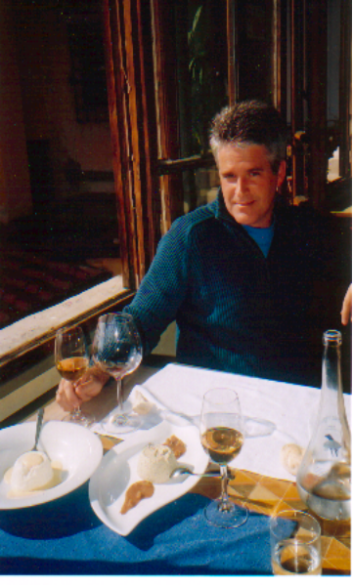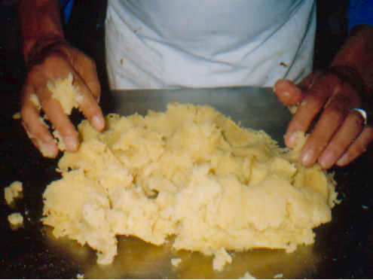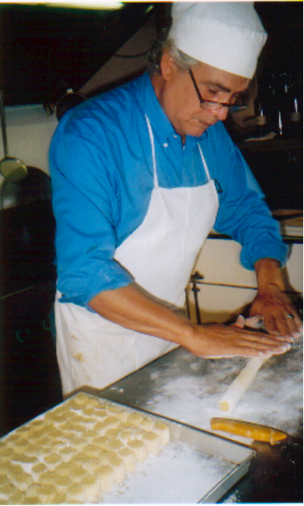Back to our abnormal schedule, we had to be up and running at 6:45 AM in order to be in the northeast suburb of Florence for our pre-scheduled private cooking class at 9:30 AM. We left at 7:15 for Settignano and ended up using the toll highway east of Florence. Except for a mile-long crazy one lane road entering into the hillside town over looking Florence (the main road was barred for some unknown reason)… crazy due to the fact that it was a two way street !! We eventually ran into a truck near the end (another car was behind us) and blessed our good fortune since we had not run into the truck halfway through !! We did out first illegal parking (no close public parking) on one of the side streets and near to our final restaurant destination. We actually arrived 20 minutes ahead of time !! At 9:30, we met our teacher chef Damiano, a 60ish owner of his own restaurant and vinoteca (wine bar), and his married daughter Silvia (definitely a family enterprise). AA took notes the entire morning as Damiano prepared a large slab of pork stuffed with fresh rosemary with further punctured holes filled with a garlic, salt and pepper mixture. The pork was cooked in milk until tender and then stewed with finely chopped vegetables including carrots and celery (I cringed at first since I detest celery but it ended up being delicious… it’s raw celery I can’t ingurgitate). Then he prepared the desserts (he had a big buffet party for 70 people that afternoon with several members of the family coming in later to help him out) with measured amounts of eggs, milk, cream and sugar and then including the following varieties : fourme d’Ambert (a light French blue cheese) with creme anglaise (infused with lemon-spiced olive oil… impossible to find in the public markets to AA’s chagrin… pistachios - the best in the world found at the base of Mount Etna in Sicily) ; a dark chocolate mousse (to be put into a crepe) with pink pepper corn and ground up green coffee bean sauce. These delicacies had to be made before the next preparation in order to chill in the fridge. All his creations were invented by himself. He is also known all over Italy for his next invention : flour-less and egg-less gnocchi !! He used starch-filled yellow flaky potatoes which he mashed and rolled into serpent-like strings (or branches) and then cut up into one-inch pieces (he needed sprinkles of potato flour on the rolling surface). These gnocchi were served with cheese from the Piedmont region. We did not do the cooking ourselves (except for some stirring) as we preferred to scour the bottom of the mixing bowls with spoons). We had the delicious lunch served by Damiano (he refused to join us) and we had three glasses of wine including the chianti from the previous day’s castello (what a coincidence ! ) and an Italian dessert wine. It was very hot out and sun was streaming on me as I had a view of Florence off in the distant boiling mist. We eventually returned to the castello at about 4:30 PM (for once not in the dark) as we were able to relax… on the eve of our departure.

Saturday, October 15th

The next morning (and night before) we packed and is was difficult since knowing that Easyjet would only allow one bag on board and we had about seven bottles of wine… we were so packed to the gills, that I had to put two grappa glasses in my coat pocket !! Our burden consisted of the following : six wine bottles including a magnum ; grappa (and the four glasses) ; 12-year old balsamic vinegar ; the ginger-perfumed olive oil ; pici (special Italian pasta) ; a tall translucent dispenser of 50% garlic, chili pepper and parsley ; a bottle of Amaretto di Serono (half the Parisian price) ; perfumed bath gel ; left over spaghetti ; two fancy wine doseurs (invented by Damiani) so that the individual glass of wine will be aerated in a glass bubble before filling it ; and fond memories.

We just had to add one last walled city before our flight (4 PM) so we drove through the countryside (avoiding the highways and getting lost on several occasions) to arrive in Lucca, about twenty miles north of Pisa. Lucca was a colony of ancient Rome in 180 BC with the Roman legacy evident in the regular grid pattern of its streets… also it was the only city we visited that was actually flat !! AA had already been there so we did not loiter (also we were running out of time and we did not want to test traffic around Pisa). Instead of parking outside, we were one of those rare cars that charged through the vehicle-less streets

Nothing notable on the flight back except for some savvy reconnoitering at the departure gate as three flights were leaving at the same time (lines all over the mini-terminal)… after hanging out in the lounge, we eventually were the last ones on the (half-empty) plane as AA had her eyes peeled on the wrong line !!

Now to conclude some interesting facts and impressions…

I could not believe the scads of tourists believing that we were off-season… error ! but what would it have been in the middle of the summer ? Tuscany has more duomos, palazzis, plazas, churches, etc than any place I know… all the major sights were within easy walking distance of the main plazas which was a pleasure even though just getting to the city center (from the car parked outside) was sometimes a hassle. At no time were we ever hassled as Florence and Pisa are well known areas for rampant pickpocketing. Car theft was possible but… why ours ? And violent crime in Tuscany is rare…

I have read in an Italian guide that “city centers are only recommended to the confident driver”. Florence was mad… and supposedly Siena, San Gimignano and Lucca do not allow non-residents to drive in the walls (I guess we screwed up in Lucca). Bicycles and mopeds are well known not to abide by traffic lights and other vehicular laws.

Driving in the countryside was mostly a pleasure thanks to the views and winding roads (which I ejoy) but you had to be aware of “roadkill”. If cars had tongues in Italy, then my Smart car would have had its trunk licked several times. I do not drive particularly slowly but I guess that the Italian drivers take themselves for Mario Andretti or Schumacher. They will even attempt to pass on blind turns… in one incident, two cars passed us on a blind turn (they seemed to be chasing each other) and the second car missed an oncoming car by a few yards as horns blared and headlights flared. On the highway, mini-Fiat Puntos cruised by us at times… I will admit that the speed limit was a miserly 90 km/hour even on the toll road… corresponding to what would be the equivalent to 130 km in France… bizarre ! Only twice did we see the carabinieri (the national gendarmes or military police… and a profession which is widely mocked by the Italians as they are treated as buffoons), one at a speed trap and another on an off ramp which we happened to use. At times, we actually got lost and I usually am a good map reader (and even AA can fend for herself)… but Italy must spend money elsewhere as the signposts are rare… in the roundabouts, there are no signs so all must be memorized on the sign 100 yards out in front (if there is one)… the gas stations did not take Visa so all was paid in cash…

Some regrets : once again, we believe that Vicky would have enjoyed this adventure (if she ever survived this text)… and maybe even my parents (but that is another long story).

Some destinations on our original planning never had out feet tread on their fertile soil : Arezzo, north of Cortona, supposedly a beautiful and rich Tuscan city known for its flourishing production and exportation of gold jewels… an entire day trip far to the east to visit Perugia, Lake Trasimeno and Castello di Reschio with the potential bifurcation to Assisi, the city of Saint Francis (now a majestic destination of Christian pilgrimage). Just too far away and no longer Tuscan but of Umbrian nature.

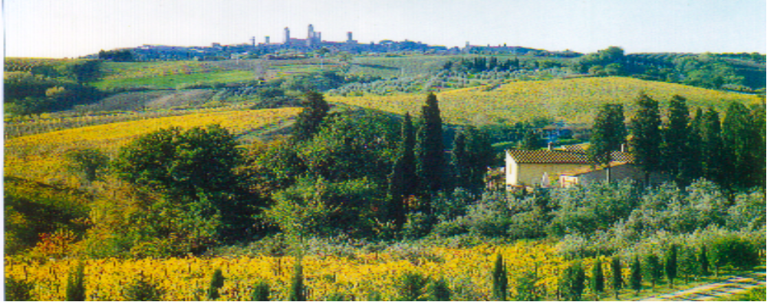
Goodbye from Tuscany !!! Photos courtesy of Antoinette and format… a joint venture.

